**LAB # 1**

**NAME:MUHAMMAD USMAN**

**CLASS: 2018-CS-164**

Objectives

* *Introduction to UML.*
* *Use case diagrams: discovering actors and use cases.*

1.Airport check-in and security screening business model

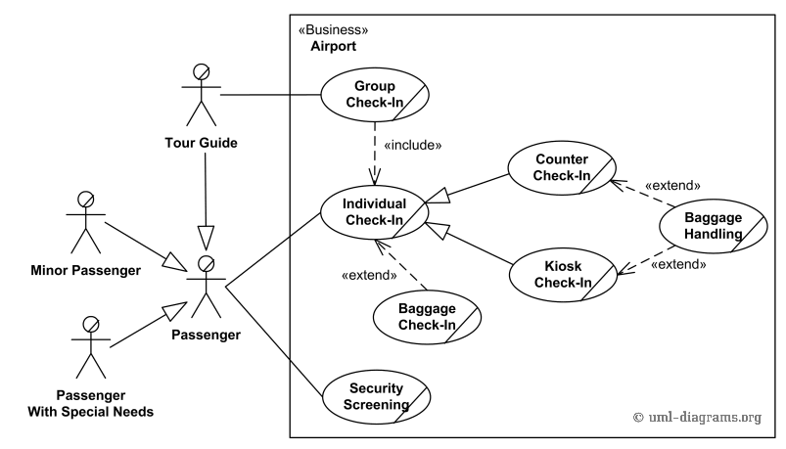

2 .Restaurant business model

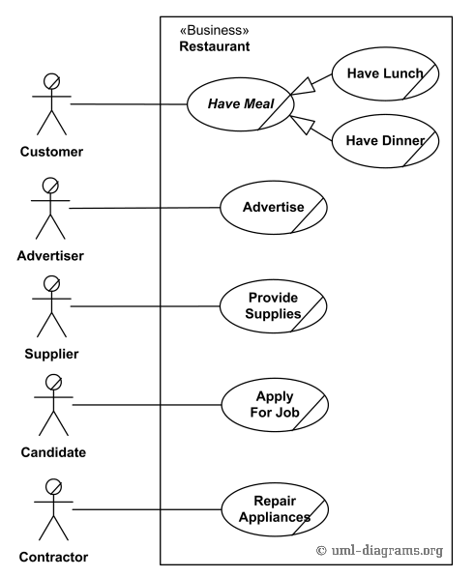

3.Ticket vending machine

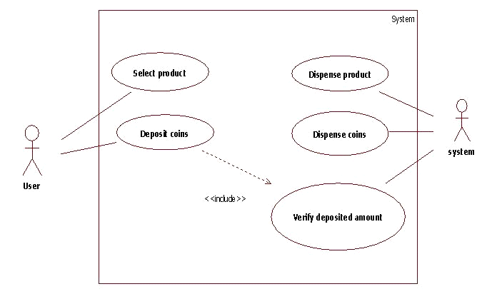

4.Bank ATM UML use case diagrams examples

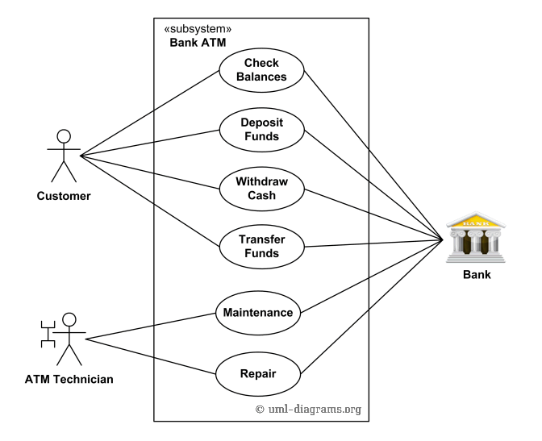

5.Point of sales (POS) terminal

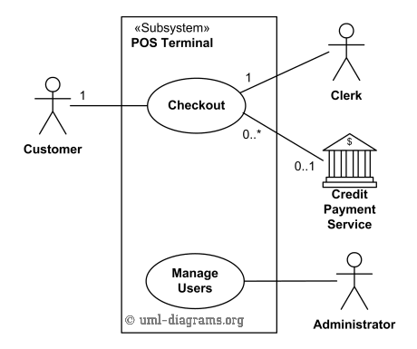

6.e-Library online public access catalog (OPAC)

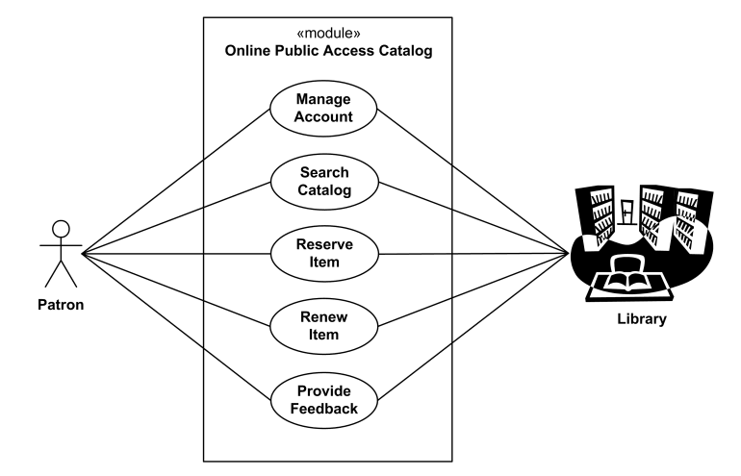

7.Online shopping use case diagrams

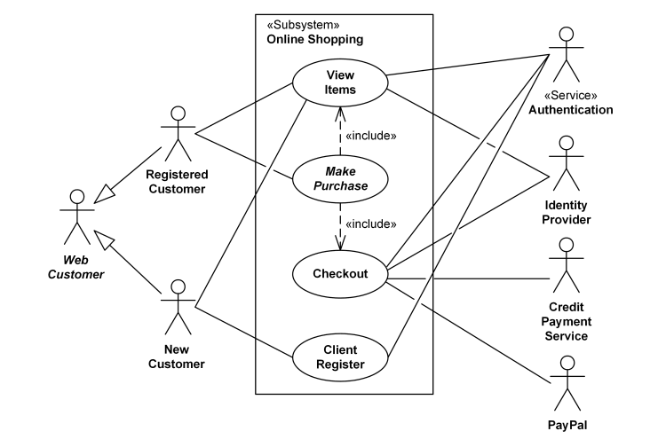

8.Website administration

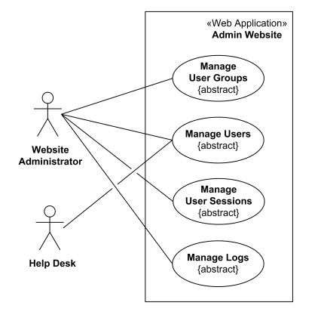

9.Hospital Management

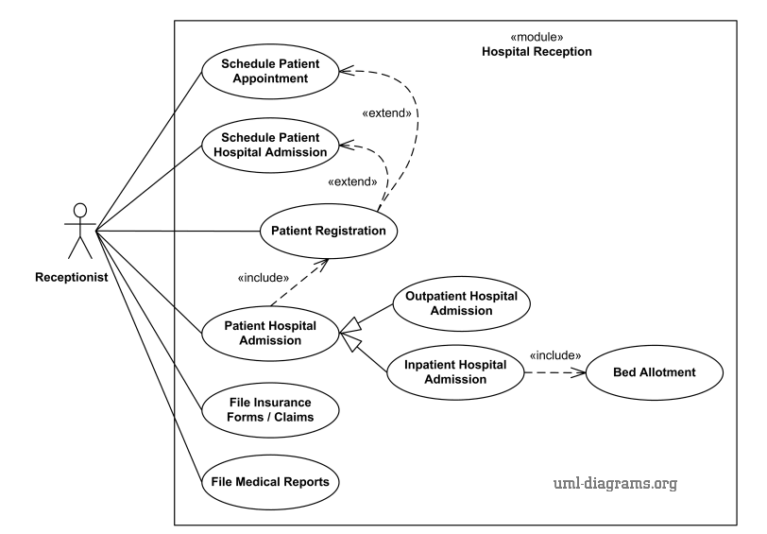

10.Radiology diagnostic reporting UML use case diagram

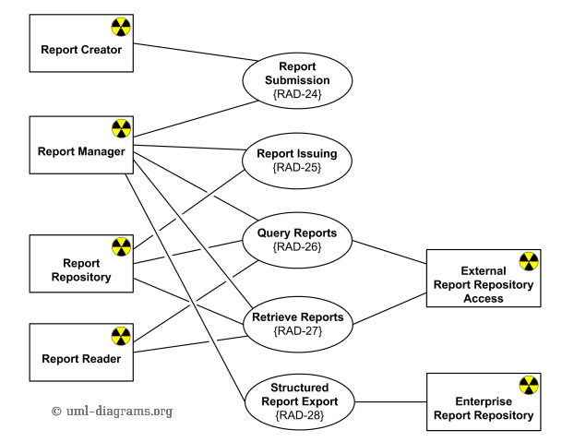

* Design a UML diagram for a centralized hotel reservation system which is working online, hotel desktop application and a customized application for travel agents.

